IMY 320

Group assignment phase 1

Group Members:

Baven Pavaday 15336728

Ryan Hartley 15016880

Introduction:

Hellpoint is a dark action science fiction RPG game which takes place on a space station known as Irid Novo orbiting around a black hole. A massive quantum cataclysm event occurred (in the game referred to as the Merge) in which every being loses their minds as their memories and bodies merged with an alternate version of themselves from a parallel universe. As a result of this, entities from a different dimension emerged (Anon2. 2017).

You play as a 3D-printed nameless character (designed by the Authority) whose intentions are unknown as you the player decide on the course that the character takes. You have been sent with one goal to “finish what was undone” by any means. It soon becomes apparent though that there are very real consequences to the actions you make in the game.

Design Overview:

Our website will attempt to capture the look and feel that you can expect when playing Hellpoint. In order to create this perception, we will be using dark colours such as black, dark purple, red to project the ominous theme of this game. A key goal of our website will be to create a simplified design which will be supplemented with striking in game visuals and the already discussed dark theme (Hafling,J 2007).

Webpage Structure:

Entrance Page:

This is the first page that the user will visit, where they will be prompted to enter their birthdate in an attempt to validate whether or not the user is old enough to view the contents. The age verification element will be placed on top of an image which fade into the black border. The black border will accentuate the image.

The games’ title will be placed at the top of the page. The age verification system is necessary as it protects unknowing/sensitive viewers by informing them of the mature nature of the pages’ contents, this also legally protects the designers of this website (Anon 2017).

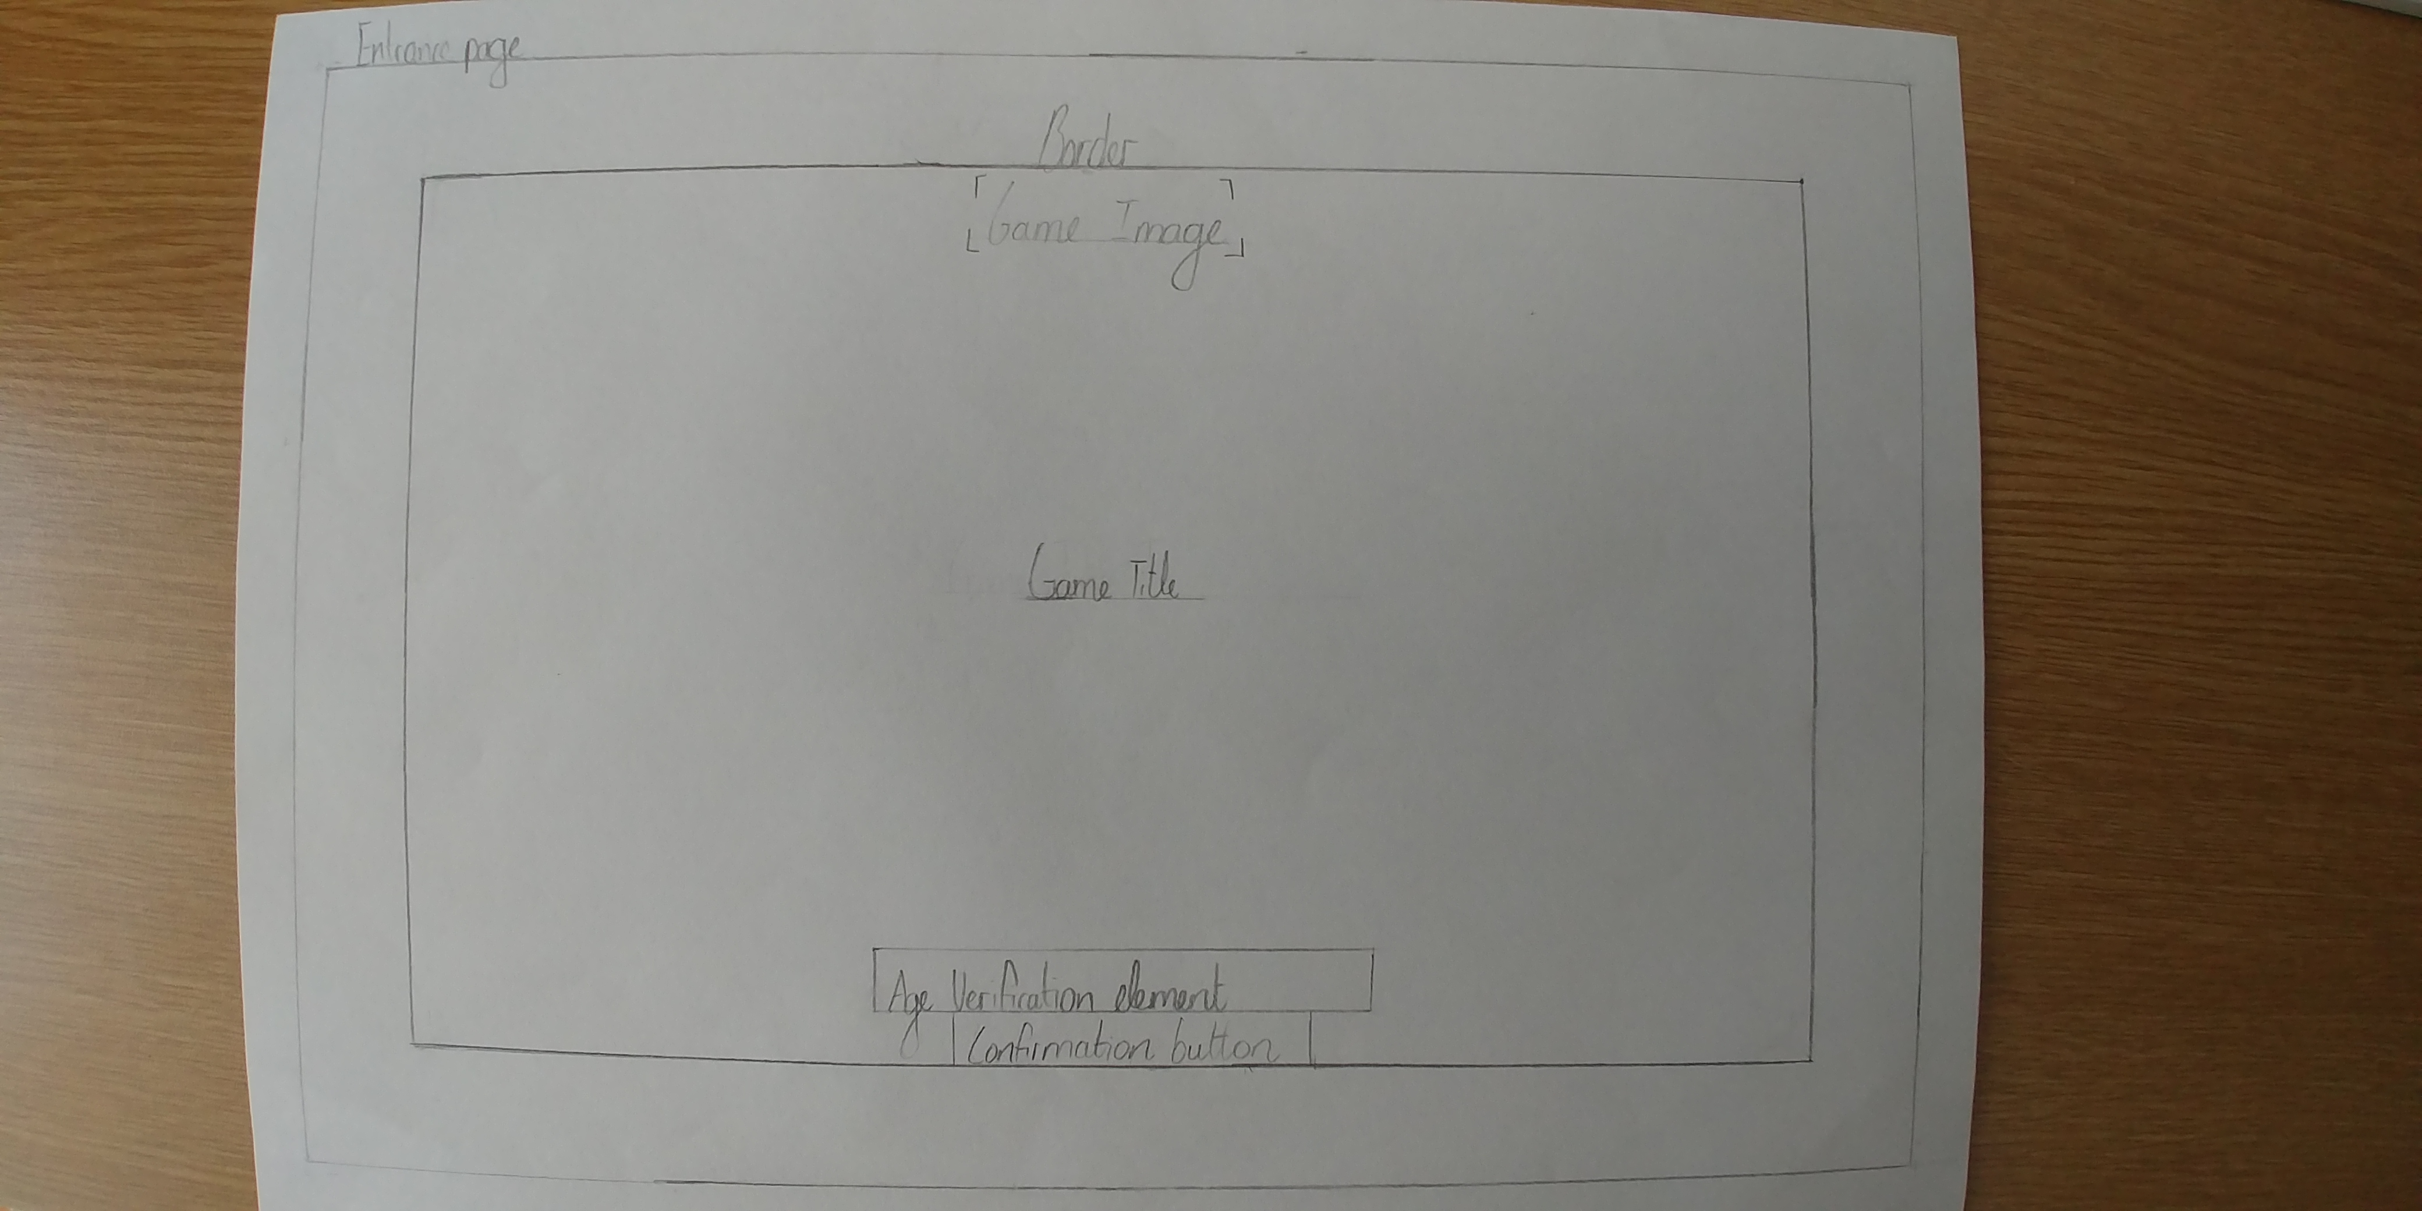

Home page:

On all the webpages that will be designed besides the entrance page there will be a menu fixed at the top of the page so that when a user scrolls down the menu stays at the top of the page. This is done so that accessing the different pages of the websites can be done with greater ease as the user is not required to scroll to the top in order to access the menu (Rutherford 2017).

The game title will be displayed over a video which will contain gameplay footage that can be played and stopped depending on what the user wants. Under this will be basic information about the game as to which platforms are supported, the release date, game genre, number of people that can play the game and the age restriction.

As the user scrolls down the page they will find information about the demo which will have a link to where the demo can be downloaded.

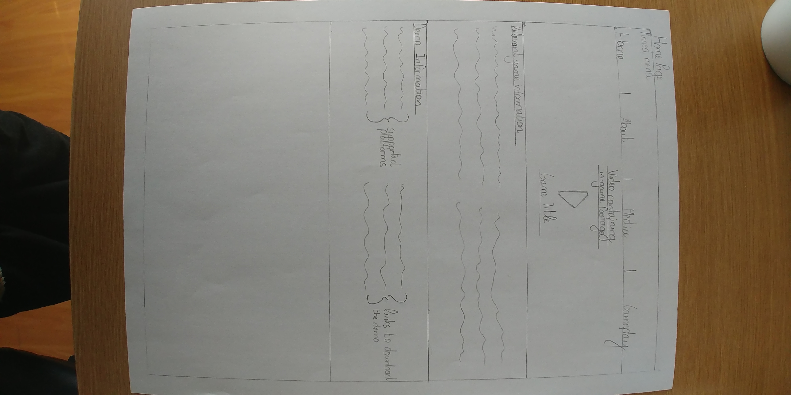

About:

This page will be used to give insight on the games story. The description of certain elements of the game will be put in text over game screenshots which will be blurred out in order to make the text more visible. This game revolves heavily around the choices the user makes in the game. This page should give an intended user an apt description of how the game works and what they can expect in the game.

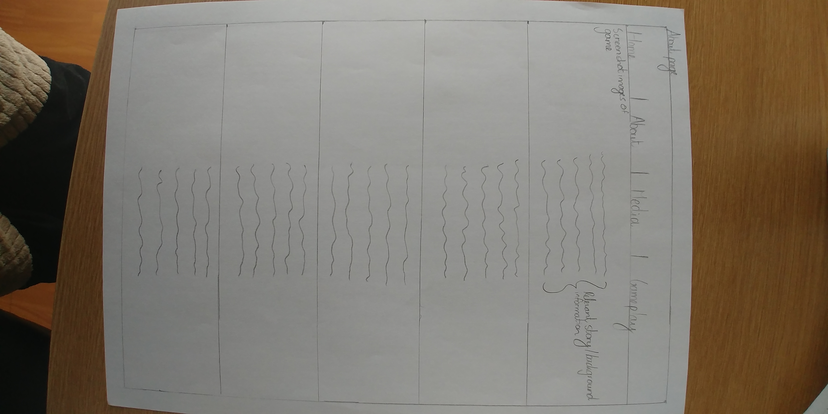

Media:

This page will be used to give further insight to games mechanics as well as the story. On entering the page a gallery will displayed containing screen shots of the game. When clicking on an image, it will fill the rest of the screen and allow the user to scroll through the rest of the images.

Under the images gallery will be a carousal containing videos. These videos will auto play and when clicked on will fill the rest of the screen as the images do. It will also provide the same means to scroll through as the images did.

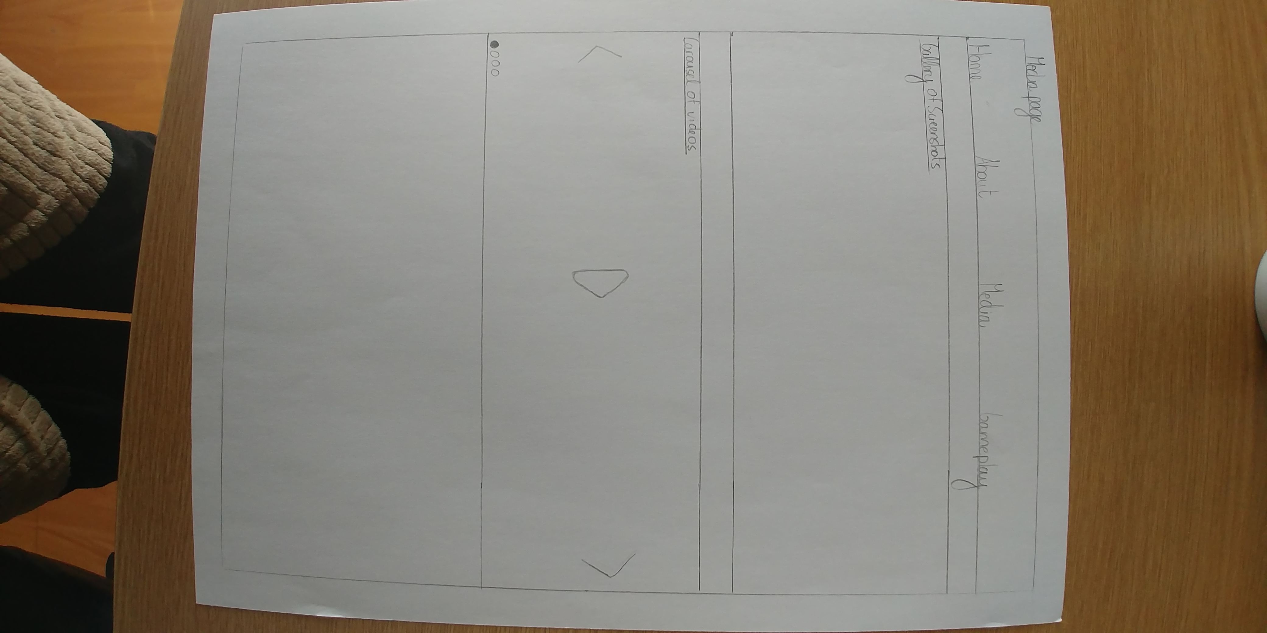

Gameplay:

The gameplay page will contain information about game elements such as the combat system and characters that the user will interact with. These elements will be used as headings where screen shots as well as a description of the selected system will be explained.

This page is implemented so that the users know what to expect from the game. It gives a more in depth view of how the game will operate.

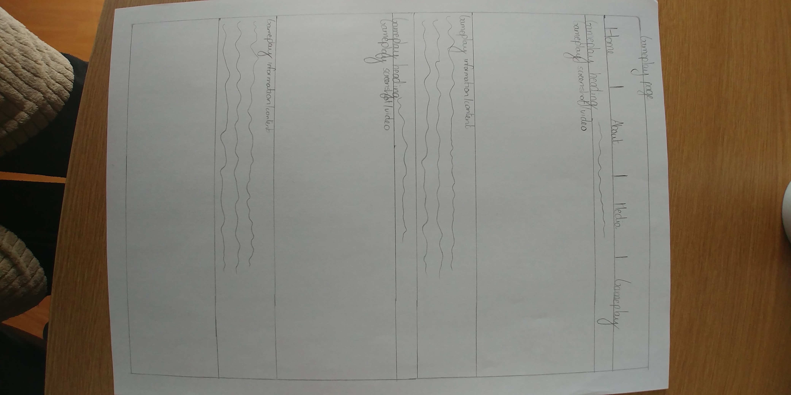

All of the above pages will make use of the dark theme that has been discussed in the design over view. As mentioned, a simplified design will be used to make the navigation of the site simple and easy to use. In total there will be 6 pages to this design with only five of them containing actual information with regards to the game, after the sign in page.

References:

* Anon. (2017), ELI5: Why do we still have age verification in videos and websites?, [www.reddit.com](http://www.reddit.com) , Available at: <https://www.reddit.com/r/explainlikeimfive/comments/6fskjg/eli5_why_do_we_still_have_age_verification_in/> [Accessed 17 Aug. 2017]
* Anon2. (2017), Hellpoint - A Dark Sci Fi RPG, [www.kickstarter.com](http://www.kickstarter.com) , Available at: <https://www.kickstarter.com/projects/hellpoint/hellpoint-a-dark-sci-fi-rpg> [Accessed 17 Aug. 2017]
* Hafling, J. (2007), Advantages of a simple web design, [www.jayhafling.com](http://www.jayhafling.com) , Available at <https://www.jayhafling.com/articles-for-seo/advantages-of-a-simple-web-design/> [17 Aug. 2017]
* Rutherford , Z. (2017), Fixed Navigation Bars: Pros and Cons, [www.awwwards.com](http://www.awwwards.com) , Available at: <https://www.awwwards.com/fixed-navigation-bars-pros-and-cons.html> [Accessed 17 Aug. 2017]